**Broker Identity**

**Launch**

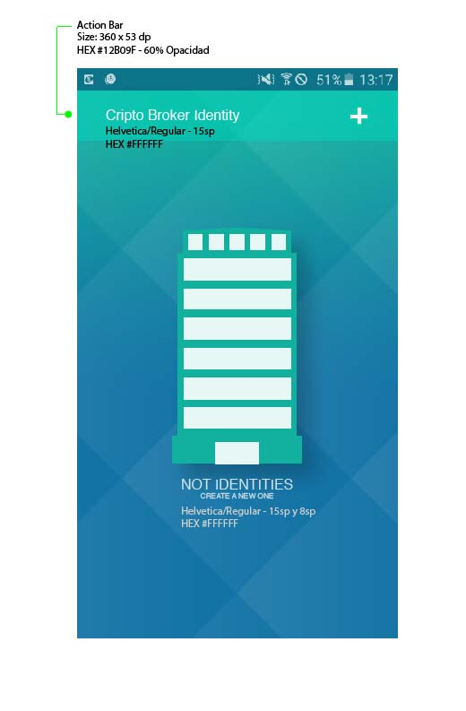

**New Identity – screen 1**

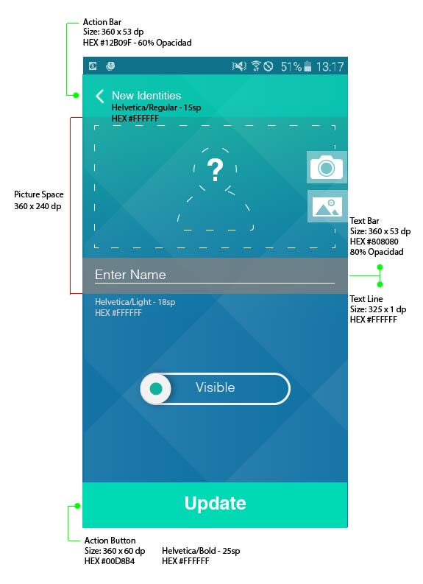

**New Identity – screen 2**

**Enter Name**

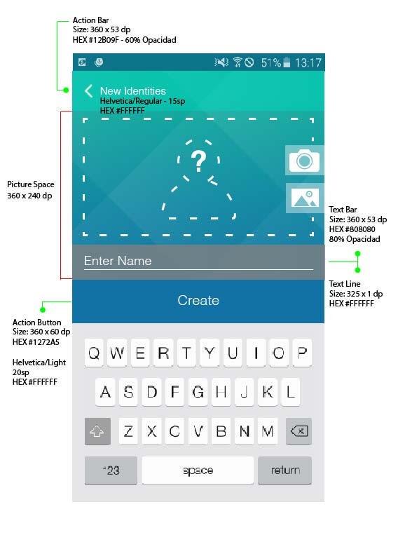

**New Identity – screen 3**

**Enter Picture**

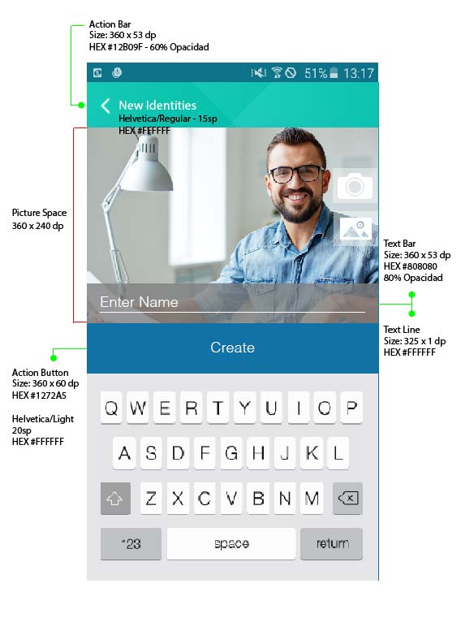

**New Identity – screen 4**

**Edit (option) - UPDATE**

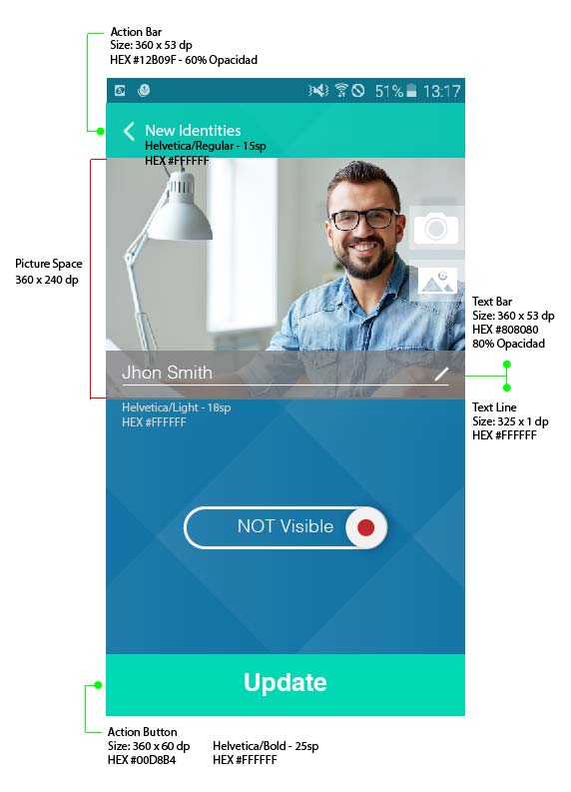

**New Identity – screen 5**

**List of Identities**

